**SPRINT 1 PLANNING**



**Author: Imagineers Team**

**Date: 10/1/2017**

**Revision history**

|  |  |  |  |
| --- | --- | --- | --- |
| **Version** | **Date** | **Author** | **Notes** |
| 1.0 | 10/01 | Thạch Nguyễn |  |
|  |  |  |  |

Contents

I. INTRODUCTION 4

1. Purpose 4

2. Audience 4

II. SPRINT 1 GOALS 4

III. SPRINT 1 BACKLOG 4

IV. SPRINT 1 TASK 5

V. SPRINT 1 DEFINTION OF DONE 7

# INTRODUCTION

## Purpose

This document describes how sprint 1 is planning. The plan describes in simple, straight forward term the processes required to ensure that the sprint 1 stories is estimated and ensures the goals of sprint 1.

## Audience

This document is created for Scrum team .

# SPRINT 1 GOALS

* This is the first sprint execution so the priority of the product as customer wishes is to have the foundation of the website and registration of the website.
* The next goal is finishing the sprint 1 selected stories with full artifacts that is defined in the “definition of done”
* Finishing the sprint 1 on time. With all the stories that was chosen to put in sprint 1
  + View site main page
  + Register via Email
  + Log in
  + Log out

# SPRINT 1 BACKLOG

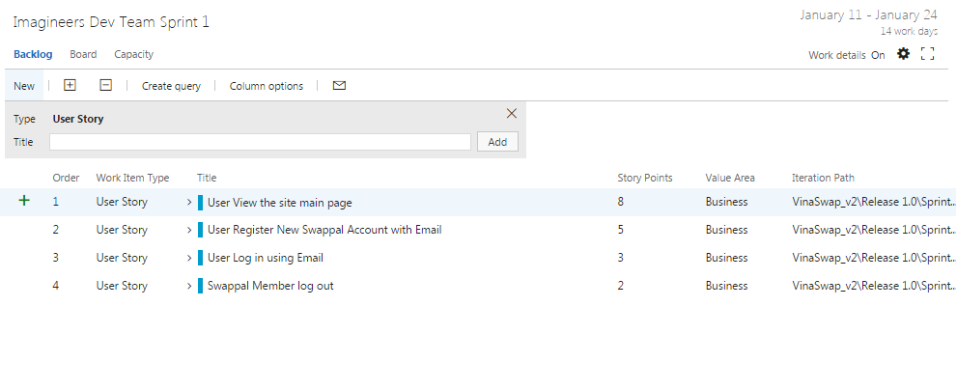

# SPRINT 1 TASK

|  |  |  |  |  |  |
| --- | --- | --- | --- | --- | --- |
| User story | Task | Assigned | Estimation (hrs) | Actual  (hrs) | Status |
| User View the site main page | Write Unit test-View main page | Chánh Trần | 8 |  |  |
|  | Review and Do Refactoring code-View Main page | Chánh Trần | 8 |  |  |
|  | Set up build-View site main page | Thach Nguyễn | 8 |  |  |
|  | Run integration test -View main page | Quang Nguyễn | 8 |  |  |
|  | Code Functions View in Main page | Chánh Nguyễn | 16 |  |  |
|  | Run test case-View main page | Tài Nguyễn | 3 |  |  |
|  | Sketch UI Design- Main page | Phương Nguyễn | 8 |  |  |
|  | Create layout-content main page-HTML & CSS & bootstrap | Quang Nguyễn | 8 |  |  |
|  | Review layout- Main page | Việt Đặng | 8 |  |  |
|  | Create simple design-View Main page | Quang Nguyễn | 21 |  |  |
|  | Create database modeling-View main page | Việt Đặng | 8 |  |  |
|  | Write Functional test-View main page | Tài Nguyễn | 3 |  |  |
|  | Write test report-View main page | Việt Đặng | 8 |  |  |
|  | Write Acceptance Test-View site main page | Tài Nguyễn | 3 |  |  |
| User Register New Swappal Account with Email | Code Register function | Chanh Tran | 8 |  |  |
|  | Review code | Chanh Tran | 5 |  |  |
|  | Create database modeling-Register new account | Thach Nguyễn | 8 |  |  |
|  | Write Unit test for Register function | Tài Nguyễn | 3 |  |  |
|  | Run test case-Register | Tài Nguyễn | 3 |  |  |
|  | Write test report-Register new account | Tài Nguyễn | 3 |  |  |
|  | Sketch UI Design-Register | Phương Nguyễn | 8 |  |  |
|  | Create simple design-Register new account | Thạch Nguyễn | 8 |  |  |
|  | Create layout Register-HTML & CSS & bootstrap | Việt Đặng | 16 |  |  |
|  | Review layout-register | Quang Nguyễn | 8 |  |  |
|  | Write Func Test case: Register function | Tài Nguyễn | 1 |  |  |
|  | Set up build-Register | Quang Nguyễn | 8 |  |  |
|  | Write Acceptance Test-Register new account | Tài Nguyễn | 3 |  |  |
| User Log in using Email | Review code-Log in | Thạch Nguyễn | 8 |  |  |
|  | Set up build-Log in | Thạch Nguyễn | 8 |  |  |
|  | Create dabase modeling-Log in | Thạch Nguyễn | 8 |  |  |
|  | Write Unit test for Log In function | Tài Nguyễn | 3 |  |  |
|  | Run Test case | Tài Nguyễn | 3 |  |  |
|  | Write test report-Log in | Tài Nguyễn | 3 |  |  |
|  | Sketch UI design-Log in | Phương Nguyễn | 8 |  |  |
|  | Create layout+ content Log in-HTML & CSS & bootstrap | Việt Đặng | 16 |  |  |
|  | Write Func Test case: Log in function | Tài Nguyển | 3 |  |  |
|  | Review layout-Log in | Quang Nguyễn | 8 |  |  |
|  | Code Functions Log in | Quang Nguyễn | 16 |  |  |
|  | Write Acceptance test-Log in | Tài Nguyễn | 3 |  |  |
| Swappal Member log out | Write Unit test for Log out function | Chánh Trần | 5 |  |  |
|  | Review code | Chánh Trần | 8 |  |  |
|  | Set up build-Log out | Thạch Nguyển | 8 |  |  |
|  | Run Test case | Tài Nguyễn | 3 |  |  |
|  | Write Test report-Log out | Tài Nguyễn | 3 |  |  |
|  | Write Func Test case: Log out function | Tài Nguyễn | 3 |  |  |
|  | Code Functions Log out | Việt Đặng | 16 |  |  |
|  | Write Acceptance test-Log out | Tài Nguyễn | 3 |  |  |

# SPRINT 1 DEFINTION OF DONE

|  |  |  |
| --- | --- | --- |
| Category | Detail | Artifacts |
| User Story Clarity | User stories selected for the sprint are complete with respect to product theme, understood by the team, and have been validated by the detailed acceptance criteria. | Product backlog/ User story |
| Tasks Identified | Tasks for selected user stories have been identified and estimated by the team. - |  |
| Product owner approval | Each finished user story has been passed through UAT (User Acceptance Testing) and signed off as meeting requirements | References : Acceptance test |
| Updating Product Backlog | All features not done during the sprint are added back to the product backlog. All incidents/defects not handled during the sprint are added to the product backlog. | Imagineers-Productbacklog |
| Environment ready | Development environment is ready with all third-party tools configured.  Staging environment is ready.  Continuous integration framework is in place  Test data for the selected features has been created | Task management : Team service  Coding: Visual code  Document: Microsoft Office |
| Design complete | Design analysis is complete as per the user story or theme.  Prototype have been created and approved by the respective stakeholders.  Use cases are developed | Imagineers-Usecase  Imagineers-Prototype |
| Unit test cases written | Unit test cases have been written for the features to be developed |  |
| Documentation Ready | Documentation to support the sprint demo is ready |  |
| Code Complete | Source code changes are done for all the features in the “to do” list.” Source code has been commented appropriately. |  |
| Unit testing is done | Unit test cases have been executed and are working successfully |  |
| Code Refactoring | Source code has been refactored to make it comprehensive, maintainable and, amenable to change. |  |
| Code checkin | Source code is checked in the code library with appropriate comments added. |  |
| Code merging and tagging | Finalized source code has been merged with the main branch and tagged appropriately (merging and tagging guidelines are to be used) |  |
| Project metrics are ready | Burndown chart has been updated regularly and is up to date. |  |
| Functional testing done | Test team has reviewed and conducted necessary manual test cases to ensure that tests are passing. All incidents/defects are reported.  100% executed test cases and 80% test cases pass.  There are no major defect occurred  Accept 20% minor defects in layout or the defect doesn’t affect system | Imagineers-TestCase  Imagineers-TestReport |
| Acceptance testing done | Each finished user story has been passed through UAT (User Acceptance Testing) and signed off as meeting requirements (see also Product Owner Approval). | Imagineers-AcceptanceTest |
| Closure | All finished user stories/tasks are marked complete/resolved. Remaining hours for task set to zero before closing the task. |  |